


Module Code & Title
CS6P05 Final Year Project
Food Share – Android App

Assessment Weightage & Type
Final Year Project Proposal (5%)

Supervisor By
Mr. Shekhar Timsina
Mr. Bishal Gharti Chhetri (GC)

Student Details
Name: Sita Ram Thing
London Met ID: 22015892
College ID: NP01MA4S220003
Islington College, Kathmandu
06 Oct 2023
Contents
1. Introduction: 1
1.1. Problem Statement 1
1.2. Project as Solutions 1
1.3. Aims and Objectives: 2
1.4. Expected Outcomes and Deliverables: 3
2. Project risk, threats and contingency plans: 3
3. Methodology 4
3.1. Waterfall Methodologies 4
3.2. Scrum Methodology (Agile) 5
3.3. Prototyping Methodology 6
3.4. Select Methodology 7
4. Resource Requirements: 9
4.1. Hardware 9
4.2. Software 9
4. Work breakdown structure: 11
5. Milestones: 13
6. Project Gantt Chart: 15
7. Conclusion: 18
Bibliography 19

List of Table
Table 1:Advantage and disadvantages of Scrum 4
Table 2: Advantages and Disadvantages of Scrum 8
Table 3: Software Requirements 10

List of Figure
Figure 1: Waterfall Methodology 5
Figure 2: Scrum Methodology 6
Figure 3: Prototyping Methodology 7
Figure 4: Scrum Methodology Evolutionary 8
Figure 5: Project Plans 11
Figure 6: Work Breakdown Structural Chart 12
Figure 7: Gantt Chart 17

Introduction:
In a world where technology continues to transform various facets of our lives, it's not surprising that the realm of charitable food donation is also benefiting from these advancements. The Weaste Food Donation App, known as "Food Share," represents a significant step forward in leveraging technology to address the critical issue of food scarcity and waste. The Food Share app seeks to revolutionize the way we approach food donations and redistribution.
Food scarcity and hunger remain persistent challenges globally, with countless individuals and families struggling to access nutritious meals. Simultaneously, an alarming amount of edible food goes to waste, contributing to environmental degradation. Recognizing these dual issues, the Food Share app aims to bridge the gap between surplus food sources and those in need, while also reducing food wastage. (Colony, 2022)

Problem Statement
Food waste is a significant global issue that encompasses the loss of edible food at various stages of the food supply chain, from production and distribution to consumption and disposal. The problem of food waste is a complex and interconnected issue with significant social, environmental, economic, and ethical dimensions. Addressing this problem requires a multifaceted approach that involves individuals, businesses, governments, and organizations at all levels to reduce food waste and its associated consequences. Addressing this problem requires local, national, and international coordinated efforts to reduce waste and ensure a more sustainable and equitable food system. Key aspects of the problem include:

Project as Solutions
This project will help to overcome the above problem statement. This application helps the food industry where donating and sharing to manage waste food. First and foremost, increased public awareness and education campaigns should inform individuals about the importance of donating edible surplus food, the safety guidelines involved, and the positive social and environmental impact it can have. Additionally, technology can play a pivotal role in connecting donors with surplus food to organizations in need, minimizing logistical challenges. Finally, incentivizing food donations through tax incentives or other financial benefits can further encourage businesses and individuals to participate in this critical effort to reduce food waste and alleviate hunger.
- Utilize the waste food and waste food reduction.
- Utilize surplus food effectively,
- Raise social awareness about food waste,
- Facilitate food donation and distribution,
- Encourage responsible food handling and safety practices,
- Promote a sense of community and social responsibility,

Aims and Objectives:
Aims and Objectives:
The food donation app aims to efficiently bridge the gap between surplus food sources and individuals facing food insecurity, with a primary focus on redistributing edible food to those in need, thereby minimizing food waste and contributing to improved food access and reduced hunger in the community.
- To learn about the Android platform and its various features.
- To understand and implement a database management system in the real world with the help of a relational database.
- To understand the working mechanism of mobile application
- To learn about API programming (Rest API)
- To learn Android UI and material design with interactive design
- To learn how to use different Adobe products which will be used in different designing stages of this app development.
- Research and implementation of current tools and technology that can be integrated into mobile applications.

Expected Outcomes and Deliverables:
- User views the history and user profile.
- To find the donate locations and effectively collect, and efficiently distribute food provisions.
- Provide opportunities for those who are interested in food donation and social work.
- The volunteers can find the donated food location and they can contact donors.
- Donners can get food distribution email message notification after completing the donation with feedback(rating)
- After contact with donors and receiver donors cannot be provided or donate food and the receiver cannot receive food for donations, they can complain to the admin.
- The food shop, restaurant, hotel, also food provided for the animal farmer for revenues generated.

Project risk, threats, and contingency plans:
Risk is described as the potential for exposure to hazard. Risk analysis is the process of examining a risk's potential effects. The following hazards might emerge in my project:

Risk and Threats | Contingency Plans
Social networking risks in the system where users do unnecessary work or crime. | Use network monitoring tools and intrusion detection systems to promptly detect and respond to suspicious network activity.
The system has increased the server cost. | User login or any server hit function control where data is saved in the local server and get from a local database.
Default to interactive designing UI/UX for the user. | Research and learn about the designing
The problem of DBMS creation and migration | Research directions and seek potential enhancements
Difficulties in getting real-time data transactions from API through mobile and web servers. | Research the following topic and get help from the supervisor.
Device or System crash | Back up the project in the Cloud
Difficult on the remote server to data fetch | Research and learn difficult parts and API authentication
Not support in old version devices | Testing and rebuilding the project

Table 1:Advantage and disadvantages of scrum

Methodology

Waterfall Methodologies
The Waterfall methodology is predicated on the idea that all project specifications can be acquired and comprehended in advance. The project manager makes every effort to fully comprehend the project sponsor’s needs. Written requirements are used to explain each stage of the project, including the expenses, assumptions, risks, dependencies, success metrics, and dates for completion. These requirements are typically provided in a single document. During the analysis and design process, developers can identify design flaws, preventing them from producing flawed code during the implementation step. Each stage of the process is delayed when one is, and vice versa. (Team, 2022)

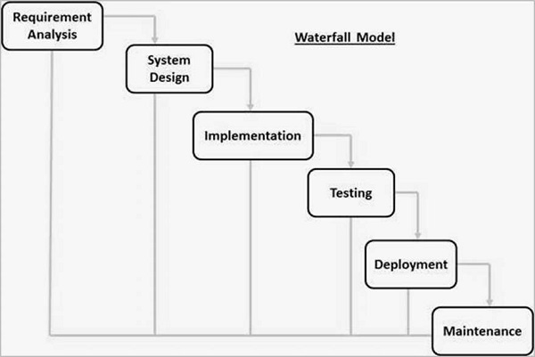
Figure 1: Waterfall methodology

Scrum Methodology (Agile)
The Scrum methodology would be a good fit for the software creation project for “Allgemein”, as it is an Agile framework that emphasizes iterative development and continuous feedback. Given the dynamic nature of the entertainment and transport industries, it is important to have a flexible and adaptive approach to software. Scrum also promotes collaboration between cross-functional teams where this project does not team, but it can be useful for a project that involves different aspects. Additionally, the Scrum framework includes regular meetings and feedback sessions, which can help ensure that the software meets the company's evolving needs and requirements.
The Scrum methodology is well-suited for projects with changing or uncertain requirements, which is often the case in software development. Scrum can help the team adapt to changing needs and requirements over time by breaking the project into smaller, manageable chunks. (S, 2023)
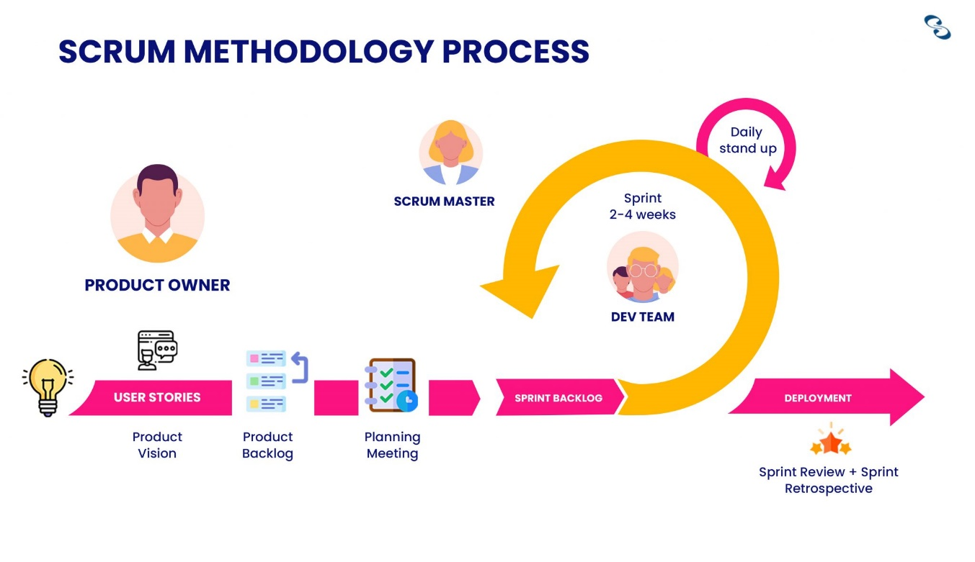
Figure 2: Scrum Methodology

Prototyping Methodology
A prototype is produced, tested, and revised until it is acceptable according to the prototyping paradigm of software development. It also lays the groundwork for the creation of the finished software or system. It functions well in circumstances where the project requirements are not fully understood. The process is iterative and based on trial and error between the client and developer. Users have an active role in the development process. As a result, problems can be found early on in the software development process. Since a prototype is ultimately discarded, the investment in creating one is completely wasted. The use of prototypes could induce too many modification requests. (Martin, 2023)
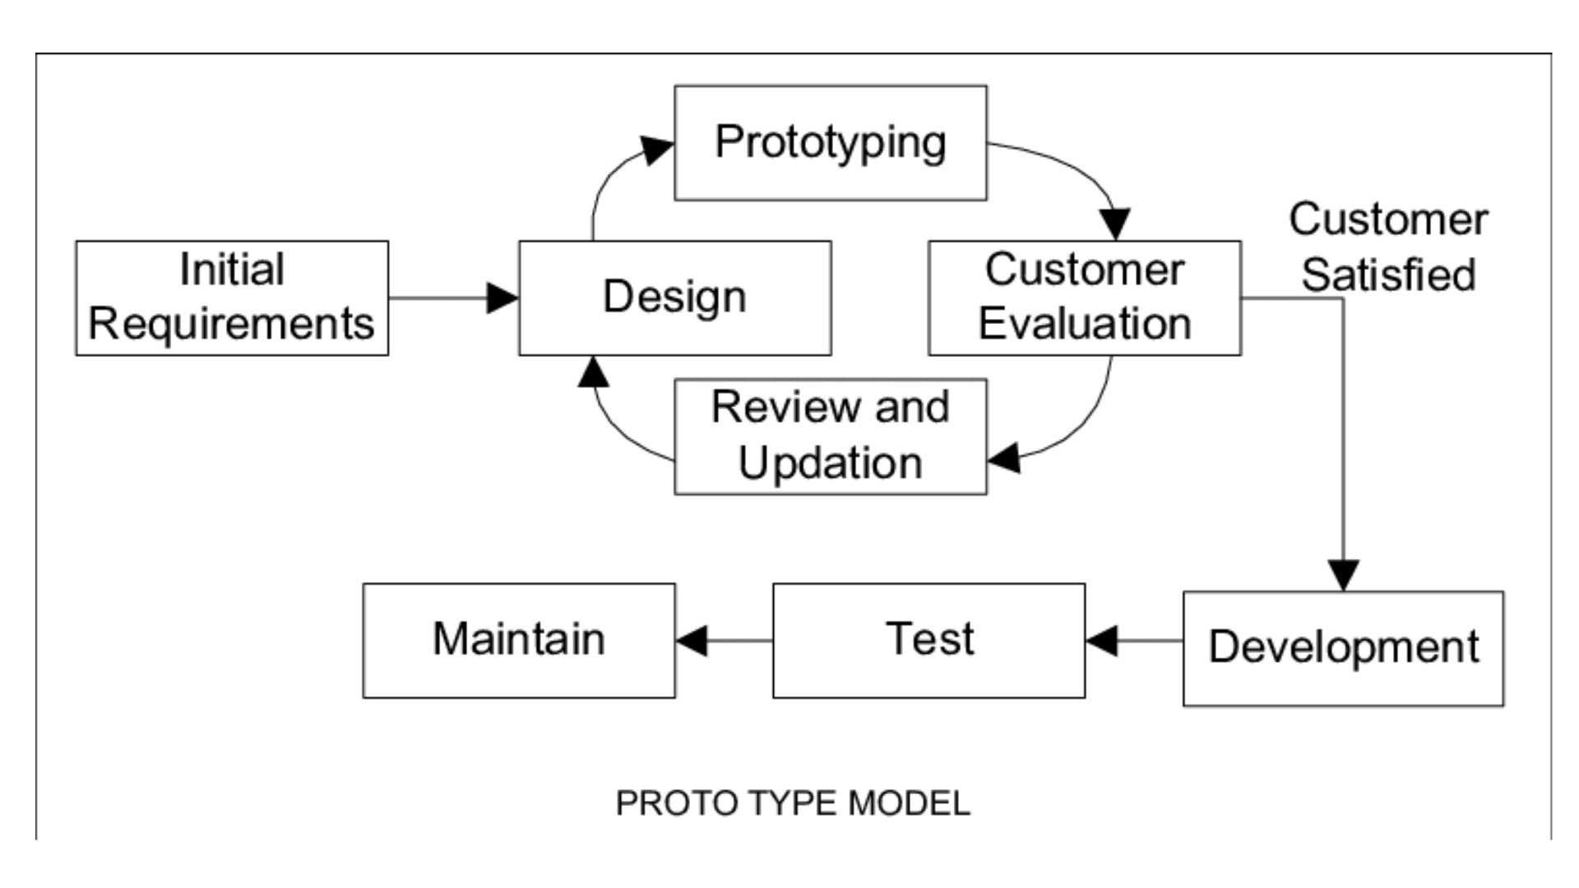
Figure 3: Prototyping Methodology

Select Methodology
Evolutionary Scrum:
The Scrum methodology is well-suited for projects with changing or uncertain requirements, which is often the case in software development. Scrum can help them adapt to changing needs and requirements over time by breaking the project into smaller, manageable chunks. It accommodates iterative development, making it suitable for projects with evolving goals. The scrum methodology can make it easy to adapt some changes and features and it can be helpful to my project. So, I will choose this methodology for the FYP project.

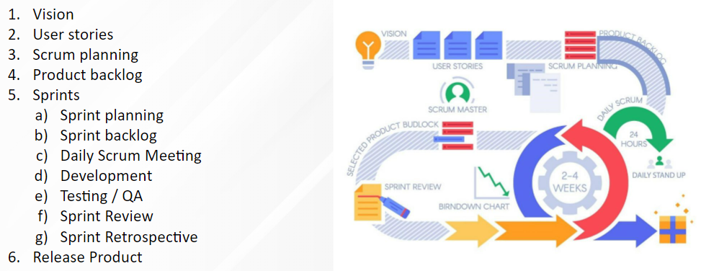
Figure 4: Scrum Methodology evolutionary

The advantages and disadvantages of evolutionary prototyping are:
Advantages | Disadvantages
It is highly adaptable and allows teams to respond quickly to changing requirements and priorities. | A solo practitioner might miss potential risks or not have the resources to address them effectively.
Weekly Standup meetings facilitate information sharing, issue resolution, and team synchronization. | A solo practitioner may struggle to gather diverse perspectives, potentially leading to tunnel vision and less informed choices.
It is highly adaptable and allows teams to respond quickly to changing requirements and priorities. | Scrum defines specific roles like Product Owner, Scrum Master, and Development Team. Working alone makes it unclear who should fulfil these roles, leading to role ambiguity.

Table 2: Advantages and Disadvantages of Scrum

Resource Requirements:
This project needs various hardware and software tools that are given below:
- Emulator: Android Mobile or Default Android Studio Emulator
- Internet Connection
- IDE: Android Studio
- Code Editor: Visual Studio Code
- Programming Language: Kotlin, Python, HTML/CSS
- Framework: Django, Rest and JetPack Compose
- Database: SQLite, Room
- Version Control: GitHub
- Tools: Draw.io, TeamGantt, Balsmiq, etc.

Hardware
The hardware requirements are given below:
  - PC with window 10
  - Android Mobile Phone

Software
The software requirements are given below:
Tools & Technologies | Version | Purpose
Kotlin  - Jet Pack Compose | 1.9.10 | Kotlin is the programming language and compose is the modern design tool kids(framework) that will be used in the front-end development of the project.
Kotlin  - Jet Pack Compose | 1.5.1
Python  - Django  - Rest Framework | 3.11.2 | Python is used for backend development in Django and Rest Framework will be used in the project.
Python  - Django  - Rest Framework | 4.2.5 (LTS)
Python  - Django  - Rest Framework | 3.14.0
Database  - SQLite  - Room | 3.8.3 | It can be used for data storage on local and remote servers.
Database  - SQLite  - Room | 2.5.2 | It can be used for data storage on local and remote servers.
HTML |  | HTML will be used to develop the webpage that displays all the necessary information that is admin panel with the help of Bootstrap.
Firebase |  | Firebase is used for real-time data analysis and push notifications.
Documentation Software & Design Tools |  | Various software is required for the process of documentation. Some of them are MS Word (Microsoft Word), Design tools (Draw.io, TeamGantt, Balsmiq,  Lucidchart) etc.

Table 3: Software requirements

Work breakdown structure:
  - Project plans
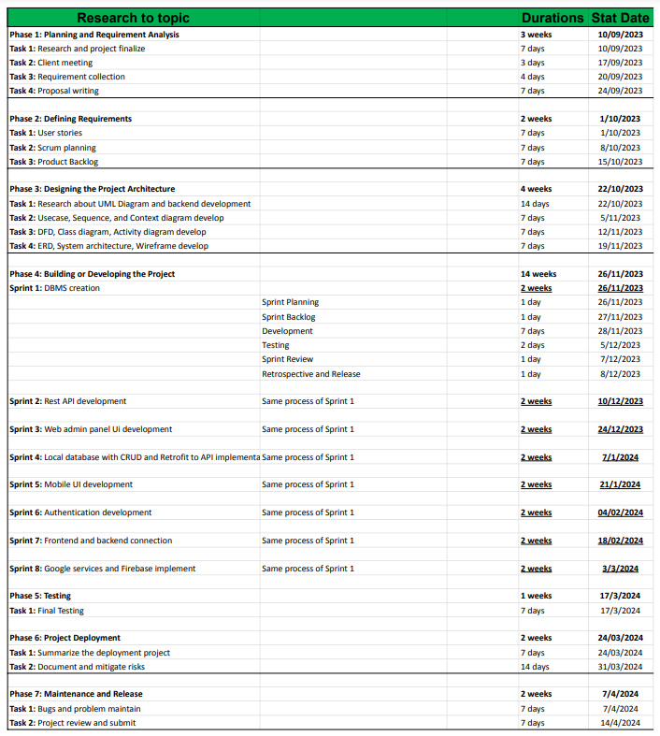
Figure 5: Project plans

  - WBS chart

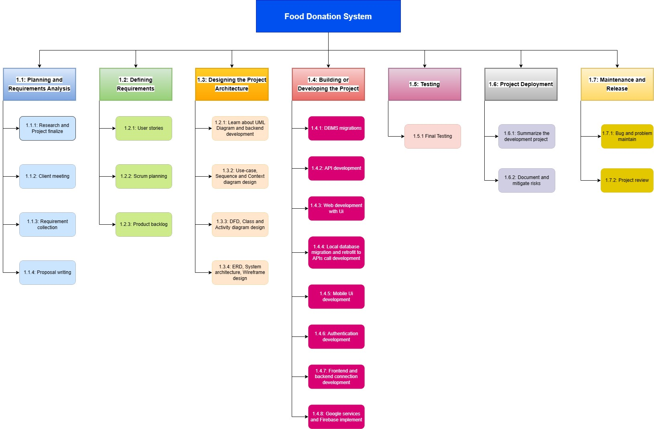
Figure 6: Work Breakdown Structural Chart

Milestones:

- Milestone 1: Topic Finalization.
Research about the FYP Topic and then topic finalization then the first milestone that was achieved. The milestone helps to focus on a FYP project.
- Milestone 2: Client Finalization.
The finalization of the client is an important milestone as the project is based on the requirements of the client. The changes are made based on the requirements of the client.
- Milestone 3: Proposal Submission.
The final proposal submission will give an idea of how the entire project is going to be. This highlights the main aspects of the final projects. It also identifies the initial requirements of the project.
- Milestone 4: Completion of Interim report.
After the submission of the proposal, the interim report is started. It is heavily based on the proposal and explains the topic in more detail. The interim report is a major part of the report.
- Milestone 5: Complete development related to web and API.
The milestone helps to achieve the development of the data transfer system from server to application for mobile and web which helps the user can easily do something.
- Milestone 6: Complete development of mobile application.
This is the completion of the mobile development of the final Food distribution mobile app which is responsible for the development of the donation system of society.
- Milestone 7: Finalize Development.
All the development processes are finalized based on the review and requirements of the client. Every unit has been tested and reviewed until this point.
- Milestone 8: Complete Testing.
The final testing of the developed unit is completed in this milestone. The development is completed from this point.
- Milestone 9: Complete the documentation.
The documentation of the project is completed which is the most important part of the project. The documentation is ready for submission.
- Milestone 10: Submit the project.
The project is reviewed for the final time and submitted to the RTE the complete the final year project after a long time developed.

Project Gantt Chart:
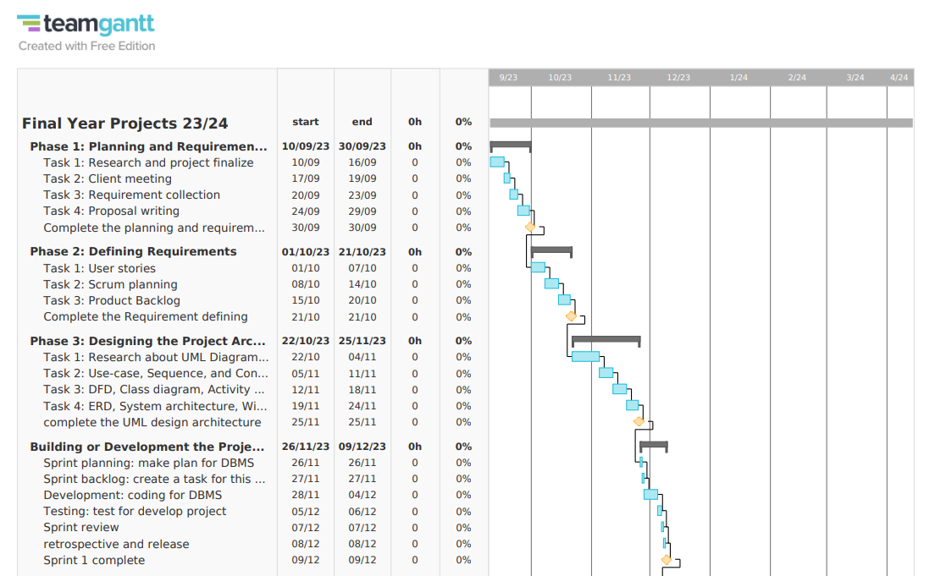
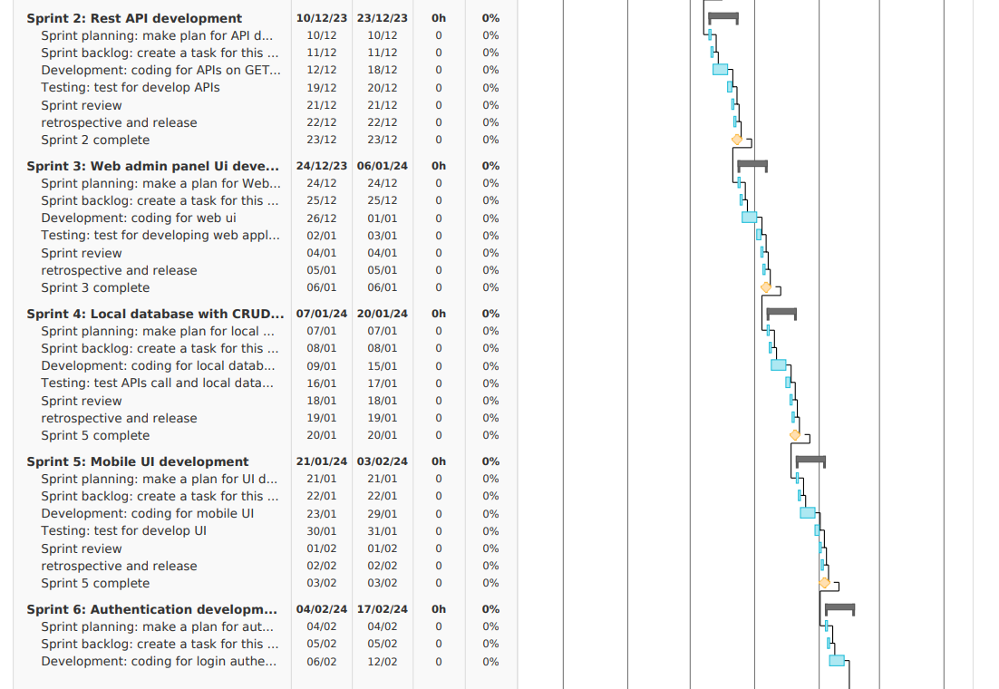

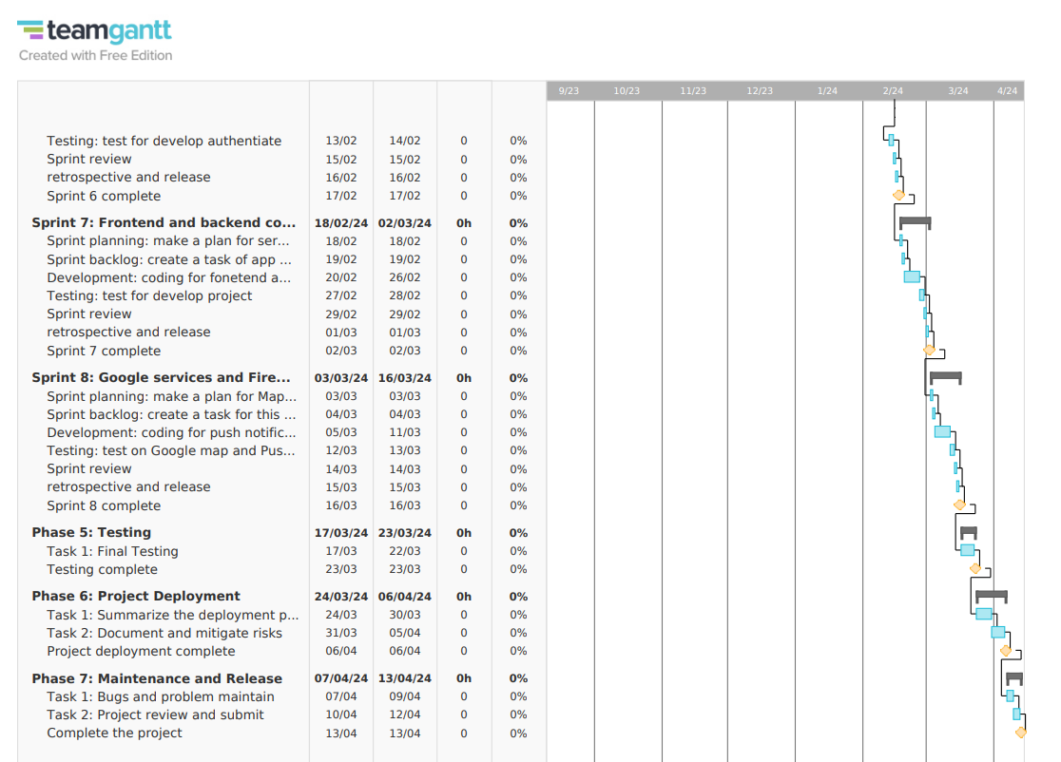
Figure 7: Gantt Chart

Conclusion:
The proposed "Food Share" app represents a significant step forward in addressing the critical issue of food waste while fostering a sense of community and social responsibility. The displaced Food Donations app has the potential to make a substantial impact on reducing food waste, alleviating hunger, and a more environmentally conscious society. It encourages individuals, businesses, and organizations to participate actively in a shared mission of reducing food waste and ensuring that edible surplus food reaches those who can benefit from it.
This project will adopt an evolutionary scrum methodology and will cater specifically to individuals in need, particularly the impoverished or homeless, who require access to fresh food and are willing to participate in food donation through the utilization of technology in a systematic manner. The project timeline estimates a completion period of 6 to 7 months from the initial start date, with this goal achieved by breaking down the project into smaller, manageable tasks.

Bibliography
Colony, R. V., 2022. Emizentech. [Online]
Available at: https://www.emizentech.com/blog/food-waste-management-app-development.html
[Accessed 04 09 2023].
Martin, M., 2023. Guru99. [Online]
Available at: https://www.guru99.com/software-engineering-prototyping-model.html
[Accessed 11 10 1012].
S, B., 2023. nimble humanize Work. [Online]
Available at: https://www.nimblework.com/agile/scrum-methodology/
[Accessed 28 02 2023].
Team, A. C., 2022. Waterfall Methodology: A Complete Guide. [Online]
Available at: https://business.adobe.com/blog/basics/waterfall#:~:text=The%20Waterfall%20methodology%20%E2%80%94%20also%20known,before%20the%20next%20phase%20begins
[Accessed 04 10 2023].

